1.Introduction

2.Main Features

2.1. common materials  
2.2. Working principle  
2.3. classification of the cam mechanisms  
2.4. characteristics  
2.5. characteristics of motion

3.kinematic synthesis  
4.results

**1.Introduction**

A member that is in contact with the cam profile and transmits power and achieves a predetermined motion, generally reciprocating linear motion or swing, is called a follower. The basic feature of the cam mechanism in the application is that the follower can obtain a more complex motion. Since the motion law of the follower depends on the cam profile curve, it is only necessary to design the contour curve of the cam according to the motion law of the follower. Cam mechanisms are widely used in a variety of automatic machinery, instruments, and steering controls. The reason why the cam mechanism is so widely used is that the cam mechanism can realize various complicated motion requirements, and the structure is simple and compact.

**2.Main Features**

**2.1. Common materials**

45, 40Cr, 9sicr, 40crMo

**2.2. Working Principle**

The mechanism for propelling the reciprocating movement or swing by the rotary motion or the reciprocating motion of the cam. The cam has a curved profile or groove, and has a disc cam, a cylindrical cam, a moving cam, etc., wherein the groove curve of the cylindrical cam is a space curve and thus belongs to a space cam. The follower is in point contact or line contact with the cam, and has a roller follower, a flat bottom follower, and a tip follower. The tip follower can keep in contact with any complex cam profile for any movement. However, the tip is easy to wear and is suitable for low-speed mechanisms with low transmission force. To keep the follower in contact with the cam always, a spring or gravity can be applied.

A cam having a groove allows the follower to transmit a determined motion as one of the operative cams. In general, the cam is active, but there are also driven or fixed cams. Most cams are single-degree-of-freedom, but there are also double-degree-of-freedom cone cams. The cam mechanism is compact and ideal for applications requiring intermittent movement of the follower. Compared with hydraulic and pneumatic similar mechanisms, it is reliable in motion and is therefore widely used in automatic machine tools, internal combustion engines, printing presses and textile machines. However, the cam mechanism is easy to wear and has noise, and the design of the high-speed cam is complicated, and the manufacturing requirements are high.

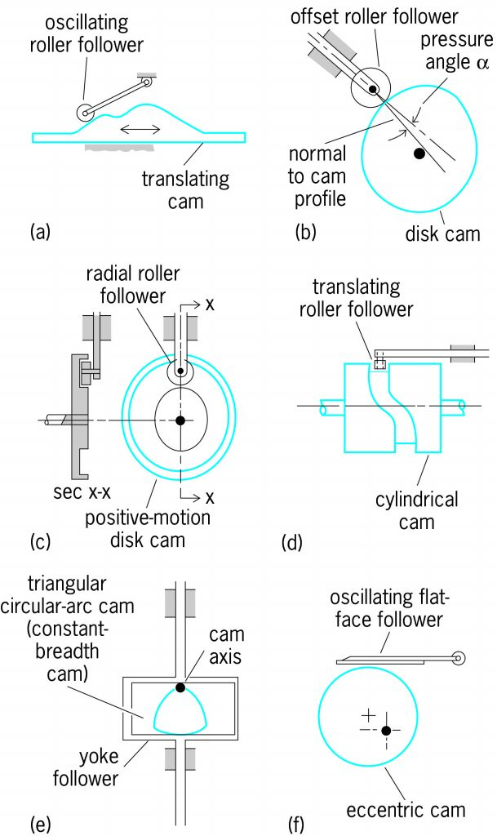

Figure   
Source: McGraw-Hill Concise Encyclopedia of Engineering

**2.3. Classification of cam mechanisms**

**By shape:**  
1) Disc cam   
2) Moving cam   
3) Cylindrical cam

**By follower type:**1) Apex follower  
2) Roller follower  
3) Flat bottom follower

**By locking:**

• Force locking: spring force, gravity, etc.;   
• Geometric locking: equal-diameter cam, equal-width cam;

**2.4. Characteristics**

**Advantage**

The structure is simple, compact and convenient in design, so it is widely used in machine tools, textile machinery, light industrial machinery, printing machinery, and electromechanical integration. As long as the appropriate cam profile is made, the follower can be given any predetermined motion law.

**Disadvantage**

• The cam is high in the secondary contact (point or line), and the point and line contact are easy to wear;   
• The cam profile is difficult to process and the cost is high;   
• The stroke is not big

**2.5. Characteristics of motion**

In the disc-actuated counter-moving disc cam mechanism with the roller, the cam revolves one revolution to perform the ascending-stop-down-stop four actions. The relationship between the follower displacement s (or stroke height h) and the cam angle 0 (or time t) is called the displacement curve. The travel h of the follower has a push and a return stroke. The cam profile curve is determined by the shape of the displacement curve. In some machines, the displacement curve is determined by the process.

However, in general, only the stroke and the corresponding cam angle are determined according to the work needs, and the shape of the curve is selected by the designer, and there are various motion laws. Conventional cam motion laws include constant velocity, equal acceleration, equal acceleration, cosine acceleration, and sinusoidal acceleration. The law of constant velocity motion has a strong rigid impact due to sudden changes in speed and is only suitable for low speed.

Equal acceleration-equal deceleration and cosine acceleration also have sudden changes in acceleration, which will cause flexible impact, which is only suitable for medium and low speed. The acceleration curve of the sinusoidal acceleration motion law is continuous without any impact and can be used for high speed. In order to make the acceleration of the cam mechanism and its speed change rate are not too large, and consider the problems of momentum, vibration, cam size, spring size and process requirements, other various motion laws can be designed.

Apply many useful motion curves, such as deformation sinusoidal acceleration, deformation trapezoidal acceleration and deformation velocity law. It can also be combined into various motion laws by using an electronic computer. It is also possible to use a motion law represented by a polynomial to obtain a continuous acceleration curve. To obtain the most satisfactory acceleration curve, an acceleration curve can be given in numerical form, and then the displacement curve is obtained by the finite difference method, and finally the convex contour is designed.

Some automata usually work with several cams. To coordinate the movements of the various parts controlled by the cams, it is necessary to prepare a correct motion cycle diagram and reduce the surface roughness before the cam design. The working conditions of the cam are air drying, clean lubricating oil, or lubricating oil with various additives. The viscosity of the lubricating oil and the choice of the oil supply method should consider the shape of the follower and the rotational speed of the cam.   
The material of the cam and the follower should be matched properly, such as hard steel and cast iron, which are suitable for high-speed sliding. Hard steel and phosphor bronze have low vibration and noise and can compensate for inaccuracies in the profile. The effect of pairing cast iron and cast iron is acceptable. However, the combination of hard nickel steel and hard nickel steel, mild steel and mild steel is not effective.

For geometric parameters, lubrication, materials and surface roughness, elastic fluid dynamic lubrication theory can also be used for comprehensive calculation to reduce wear.

Source: machinemfg.com

**3.Kinematic Synthesis**

for obtaining the kinematic synthesis of the cam mechanism, we have to first design the pitch profile -that is trajectory followed by the trace point- and then we calculate the cam profile by considering the roller radius or the flat contact.

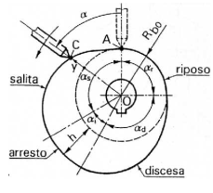

Figure

For the analytical synthesis of the cam the kinematic inversion is used, which assumes that instead of cam rotating, the follower is rotating and the cam is still in the position. The value of $α=0$, is used for the initial position of the follower with respect to the cam. This position corresponds to the configuration in which the follower begins to rise on the cam. Knowing the follower motion curve, $y(α)$, we can add the roller radius $R_{b0}$, so to obtain the pitch profile:

$r_{0}\left(α\right)=R_{b0}+y(α)$ [3-1]

Considering a cam mechanism, with a follower having a translating movement (which is the configuration of the studied project), we can define the pressure angle as following, considering $C$ as the center of the cam and $K$ as the center of the curvature:

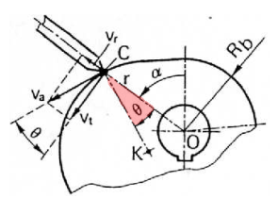

Figure

The pressure angle is: $θ=K\hat{C}O$ [3-2]

To calculate $θ$ we relay on the relative kinematic approach.  
the motion of the contact point C, is described by two components:

1. Radial motion:

$v_{r}=\dot{y}=\frac{∂y}{∂α}.\frac{∂α}{∂t}=y^{'}ω$ [3-3]

1. Drag motion:

$v_{t}=ω\overline{OC}=ω(R_{b0}+y)$ [3-4]

So, the absolute velocity is given by:

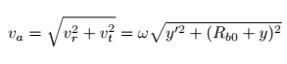

[3-5]

Since the absolute velocity is tangent to the pitch profile, and so, normal to the CK which is the radius of curvature, the pressure angle is given by the angle between the absolute velocity and the drag velocity:

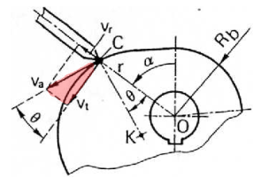

Figure

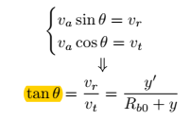

[3-6]

For evaluating the radius of curvature, we use the Coriolis theorem. obtaining the acceleration in point C, we get:

 [3-7]

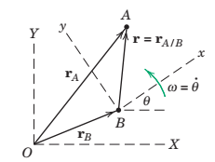Obtaining the velocity and acceleration of a generic point A, with respect to the rotating point B, we have:

Figure



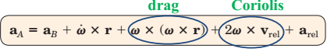

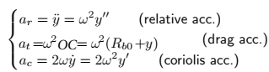So, our acceleration components will be:

[3-8]

[3-9]

[3-10]

Now, to obtain the radius of curvature $ρ_{0}$, we project the absolute acceleration, along the normal direction to profile, so the direction of the radius of curvature, using the pressure angle we obtained above:

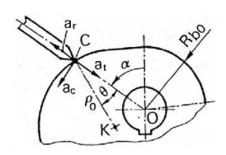

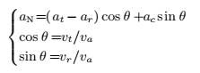

Figure

The projection of $a$ on the direction of the radius of curvature, will give of us a new drag acceleration, considering the radius of curvature, as the radius of rotation:



So,



substituting the radial, drag and absolute velocity, we will obtain:

$ρ_{0}=\frac{{\left[y^{'2}+{\left(R_{b0}+y\right)}^{2}\}\right]}^{\frac{3}{2}}}{{\left(R_{b0}+y\right)}^{2}-\left(R_{b0}+y\right)y^{''}+2y^{'2}}$ [3-11]

Note that, $ρ_{0}$ can be negative and in that case the cam profile is concave.

The cam profile radius of curvature, now, can easily be obtained by subtracting the roller radius:

$ρ=ρ_{0}-R_{r}$ [3-12]

considering the following figure, we can obtain the polar coordinate of the cam profile, from the triangle CPO, as follows:

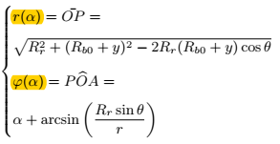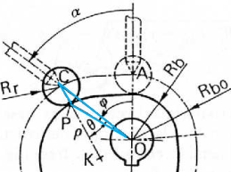

Figure

[3-13]

[3-14]

**4.Results**Using MATLAB, after choosing and obtaining the proper motion law for our system, the cam mechanism was designed. Given the motion law, the follower motion with respect to master angle, is derived at the values are stored in the 2 by 2 matrix “C_vect”. Giving a value equal to 100 to the base radius, according to the radius chosen is the ADAMs software, the analysis is started by a four-option question asked by the code to define the type of cam you have:



Figure

As it is shown in the code, the four cases correspond to the four different cams we could have. As it is shown, we can have positive cams with clockwise rotation, negative cams with clockwise rotation, positive cams with counter-clockwise rotation and negative cams with counter-clockwise rotation, in which for the negative cams, the matrix of follower motion with respect to the master angle is inverted in sign, and also, for counter clockwise rotation, the vector alfa, which is the master angle, is inverted as well.

Choosing one of the cases, the kinematic relationships is obtained.

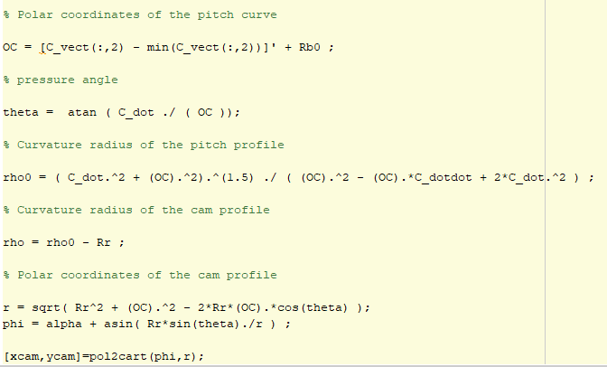

Figure

The first equation corresponds to the equation [3-1]. Since C_vect is the absolute position of the follower and not the relative position with respect to the base radius, subtracted by the initial value, which is also the minimum value, so that we only have the deviations from the unit base radius and not the minimum value. Then the second, third, fourth, fifth and sixth equation respectively corresponds to equation [3-6], [3-11], [3-12], [3-13] and [3-14].

In the end the diagrams are plotted for a positive clock-wise cam, as an example:

1. 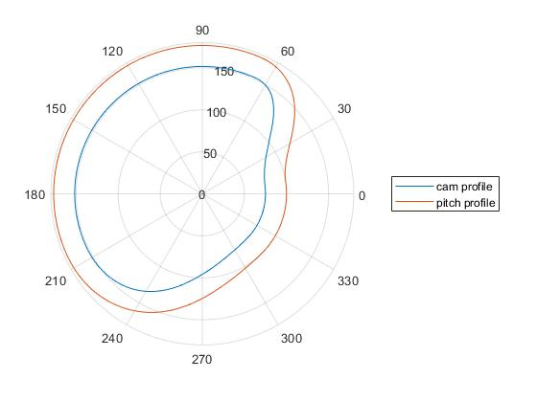**Cam and pitch Profile**

Figure - plot of cam and pitch profile

1. **Changes of radius OC with respect to the master angle**

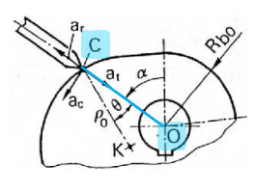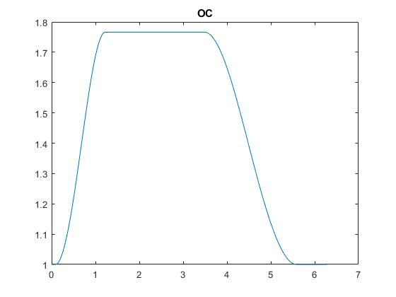

Figure -plot of the radius r with respect to the master angle

In the above plot, the minimum on the y axis is equal to base radius which is equal to one.

1. **Pressure angle $θ$ with respect to the master angle.**

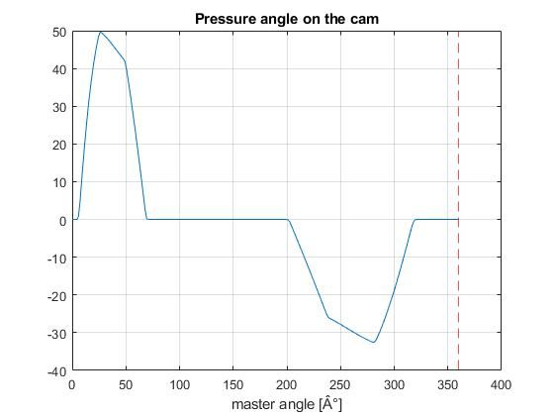

1. **the product of $ρ$ and $ρ_{0}$**

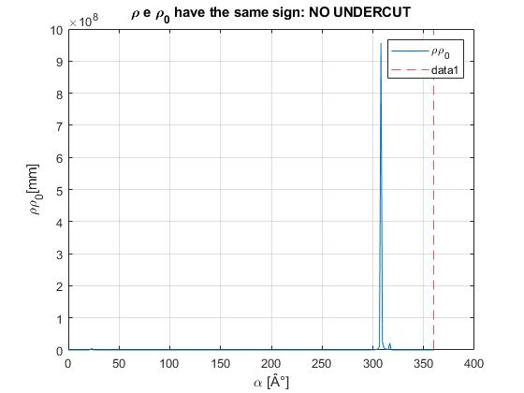

Since the product of the product of $ρ$ and $ρ_{0}$ are positive in all values of master angle, we do not have any undercut.